Annual Report
2018
Tobiloba Ajayi
The Let Cerebral Palsy Kids Learn Foundation
12/31/2018
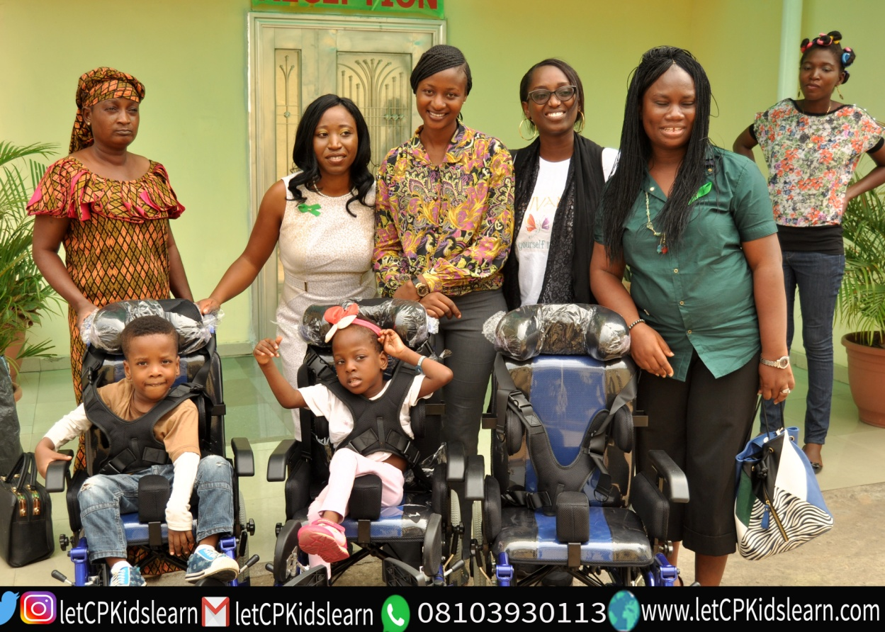

The Let CP Kids Learn Project Annual Report 2018
  - Table of Contents
Who We Are 3
From The Chief Responsibility Officer 4
2018 Impact Across Our Thematic Areas 5
-Public Awareness 5
- School Readiness Assessments 5
- School Placement Support 6
- Referrals 6
-Teacher Training 7
-Inclusive Education Support for Schools 7
Additional Information 8
Money Matters 9
You Made It All Happen 10
How Can You Help 11

Who We Are
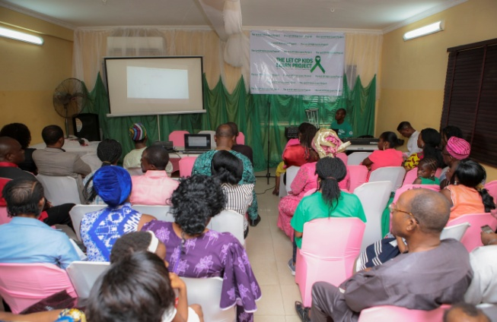

Our Vision
A Nigeria where children with Cerebral palsy are offered inclusive mainstream education as a first option as a right and not as the exception that currently exists
Our Mission
- Changing public perception about the intellectual capabilities of Children with Cerebral Palsy through public enlightenment programmes.

- Encouraging and supporting parents to raise their children with Cerebral palsy in their own homes and communities, including educating them in mainstream schools.

- Providing Support to Parents in the Management of Cerebral Palsy using a robust referral system

- Providing support to teachers, tutors and schools to enable them enrol, engage and support children with Cerebral palsy in mainstream classrooms

- Providing trainings and support materials to both families and teachers to help them understand Cerebral Palsy and ways to teach children with the condition.

From The Chief Responsibility Officer
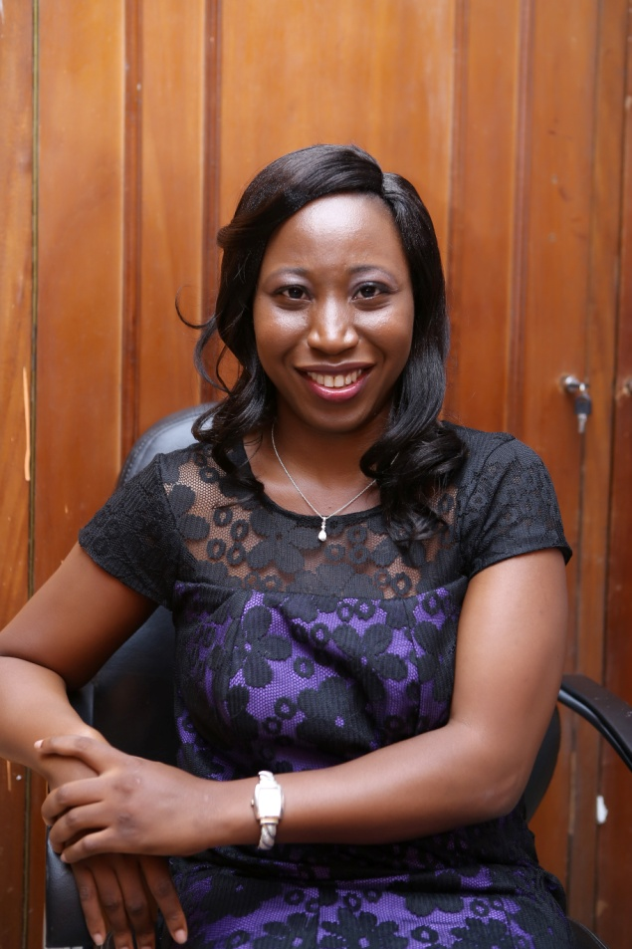

This Let Cerebral Palsy Kids Learn Foundation ( yes, Foundation) has had a phenomenal year.
One thing that last year taught us as an organisation was that our concern was valid. Very valid!
What started as a discontent last year has in this year, grown even more. It has grown into a national movement that is changing perceptions about the intellectual capacities and educational capacities and possibilities open to children with Cerebral Palsy.
It has indeed snowballed into a national movement that has challenged age long beliefs, cultural norms and presumptions about what is possible with a Cerebral Palsy diagnosis and is continuing to change narratives along the way.
This year was our year of ‘improving our model’. With proof from last year in the capacity of children with Cerebral Palsy to learn alongside their typical peers in regular classrooms, we set out this year to improve on our model of service delivery and help as many children with Cerebral Palsy as we could reach access an education that is inclusive and prepares them for life.
This year has been a roller coaster in all the ways possible, but as we close this year, we can look back and indeed say that we have continued to fulfil our mission of promoting inclusive mainstream education for children with Cerebral Palsy in Nigeria
Thank you for your continuing support.

Tobiloba Ajayi
Chief Responsibility Officer

2018 Impact across Our Thematic Areas
Public Enlightenment
This year, we have continued to use social media as a tool to reach as many people as we can with the Let CP Kids Learn Message. We also used traditional media as we appeared on both TV and radio interviews alongside quite a number of public speaking engagements. All these reached thousands of viewers and helped us reach more people who needed or services-both families and schools.
In March, we ran a 31 day awareness campaign online where we shared one Cerebral palsy fact every day for the month of March.
We also had twitter chats with colleagues on inclusive education
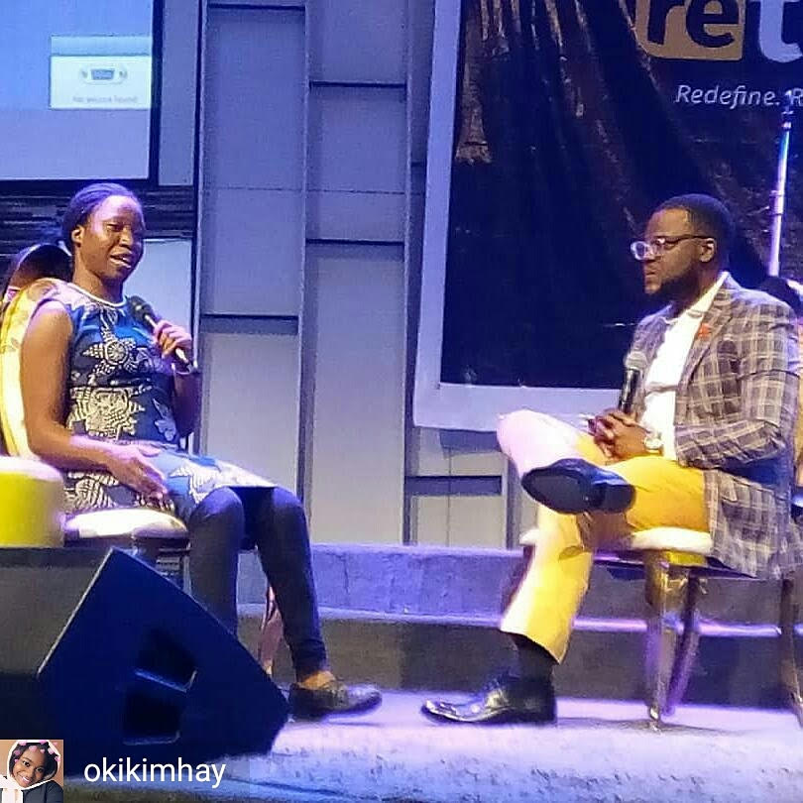
Speaking to over 2000 people about Cerebral Palsy at Lofty Heights Conference 2018
Physical and School Readiness Assessments
We provided Physical and School Readiness Assessments to 107 people. 63 males,44 females aged between 6 months and 32 years.
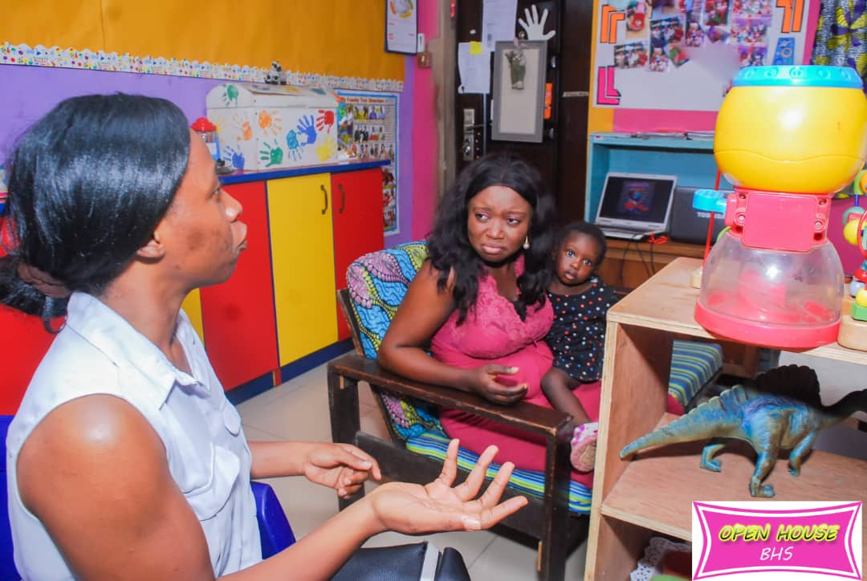
Figure 1 Post Assessment Counselling at Bethel Hill Schools
School Placement Support
30 children were placed in mainstream schools this year across 17 schools in 3 states of the country.

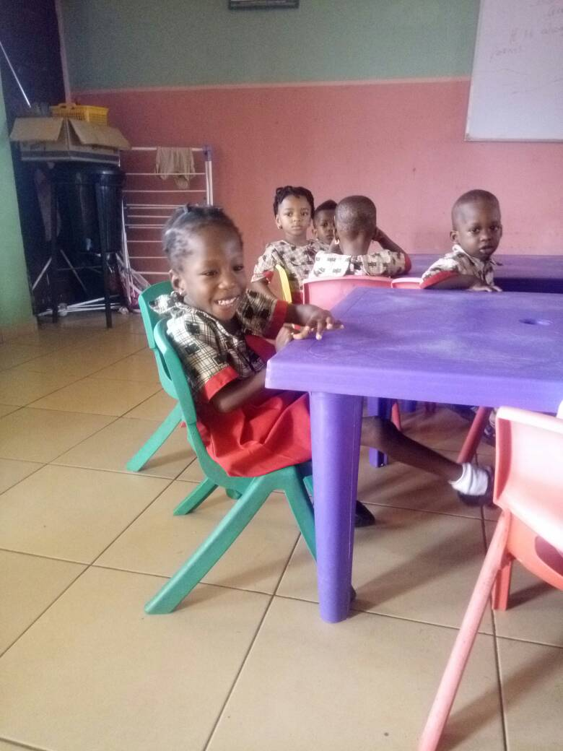
Daniela in School for the first time in April 2018

Referrals
All 107 people assessed were given referrals as necessary
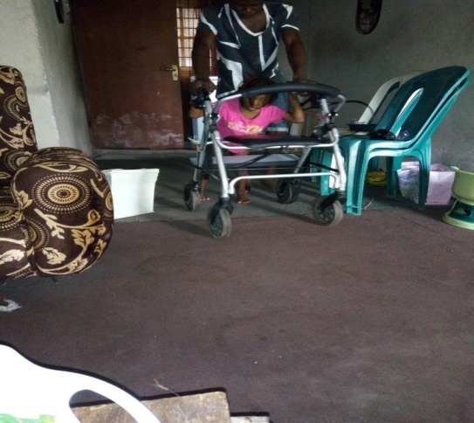
One of Our Clients trying out a new mobility aid as referred

Teacher Training
We trained 200+ teachers across 10 states this year on appropriate methods and techniques for teaching children with Cerebral Palsy in mainstream classrooms#
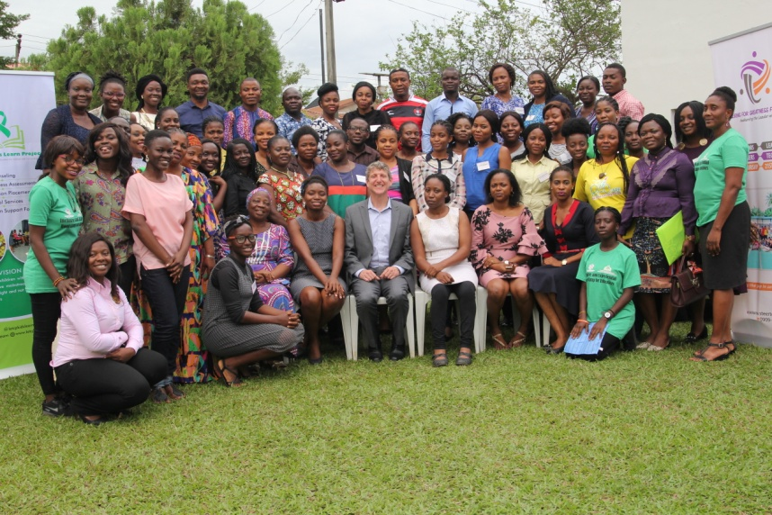
Inclusive and Experiential Education Boot camp for Educators
Inclusive Education Support for Schools
We currently provide ongoing Inclusive Education Support to three schools in Lagos State

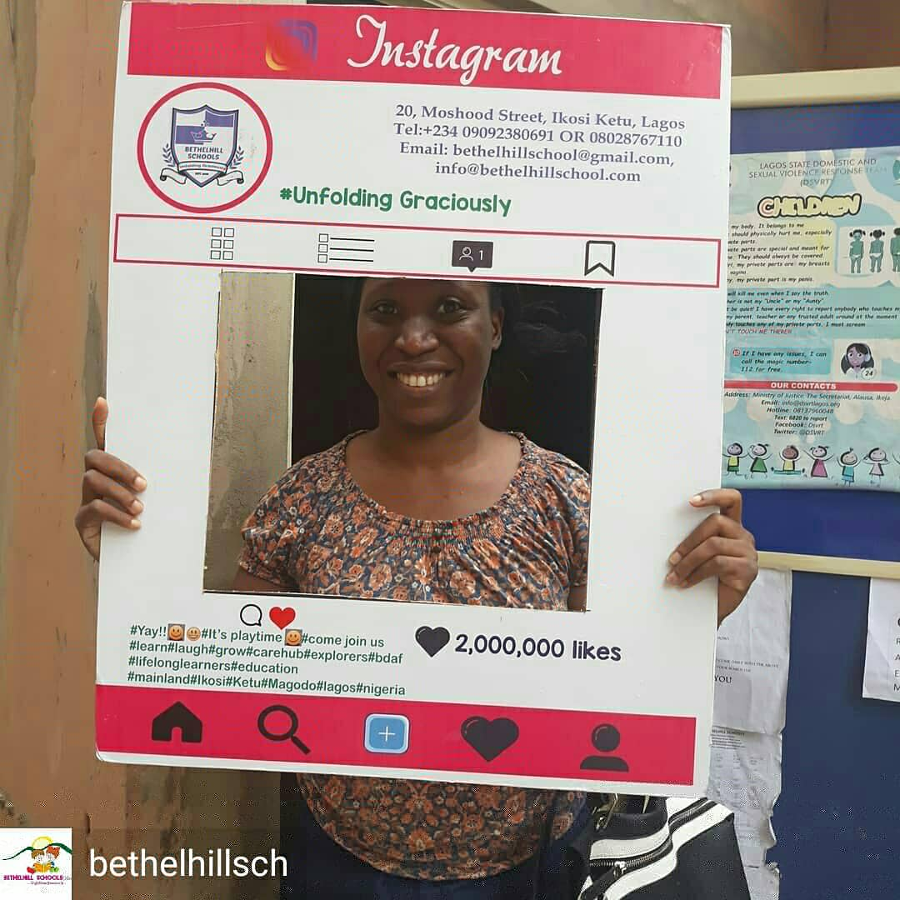
The third school we provide ongoing support services for,
Additional Information
Awards
The organization received two major awards in the course of the year

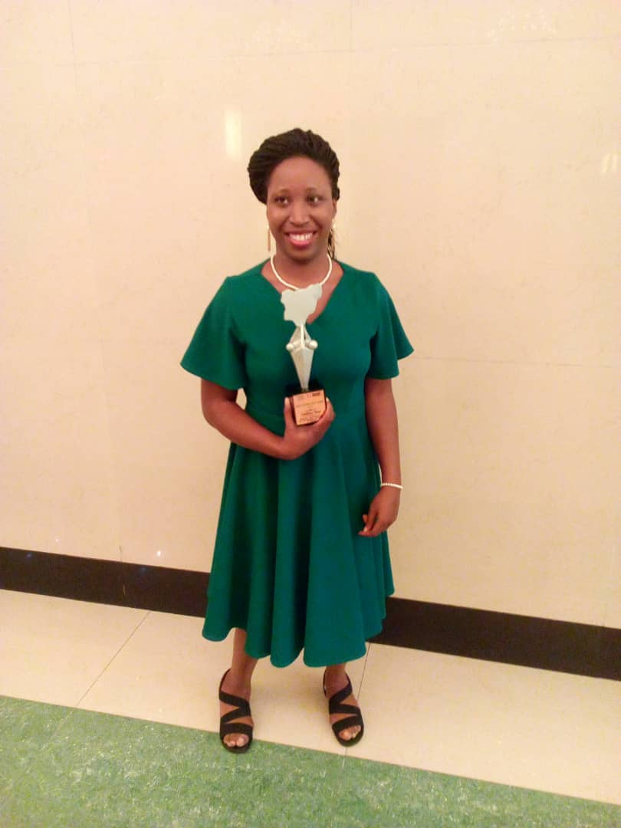
Receiving The La Mode Magazine Award
Donations and Partnerships
In Partnership with the Givinas Foundation, three children were given appropriate Cerebral Palsy wheelchairs to enable them have the proper posture, and aid the movement required to get an education.
The Kokun Foundation also supported the organization with a cash gift
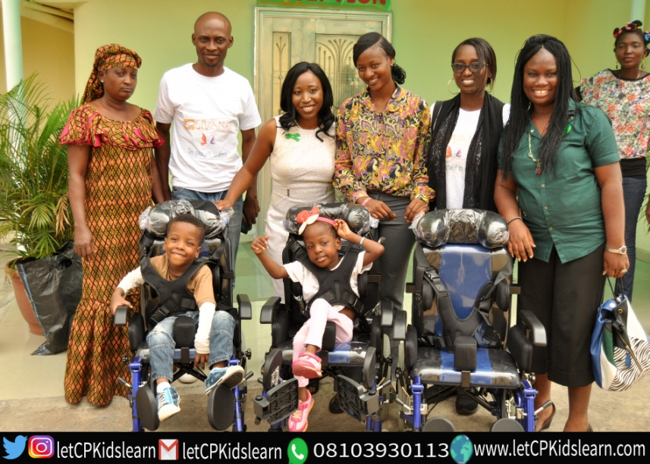
Three Cerebral Palsy Wheelchairs Donated by the Givinas Foundation

Losses
To our utmost dismay and devastation, we lost two of our clients this year. The two were children under the age of 5. One male and one female.

What Did This Cost?

Total Income: 1,598,300

Total Expenditure: 996,400

You Made It All Happen
We are incredibly grateful to all our donors -individual and corporate who with their generous donations we were able to make all these people smile.
Without your unflinching support, all these would have remained a beautiful dream and all these families would still be in the uncertainty that a cerebral palsy diagnosis can bring.
We look at all the beautiful smiles on the faces of our children and their parents and we thank you.
We are full of gratitude to all our volunteers who gave of themselves selflessly to help us achieve our goals this year. Thank you does not begin to scratch the surface of our gratitude to you for your selflessness.
To all the parents who trusted us enough to allow us to share in your journeys this year, you are the real rock stars. Thank you for trusting us. Thank you for believing with us when we said your children could learn. Thank you for sharing with us every milestone and in some cases setbacks.
Thank you for allowing us to be a part of your journey.
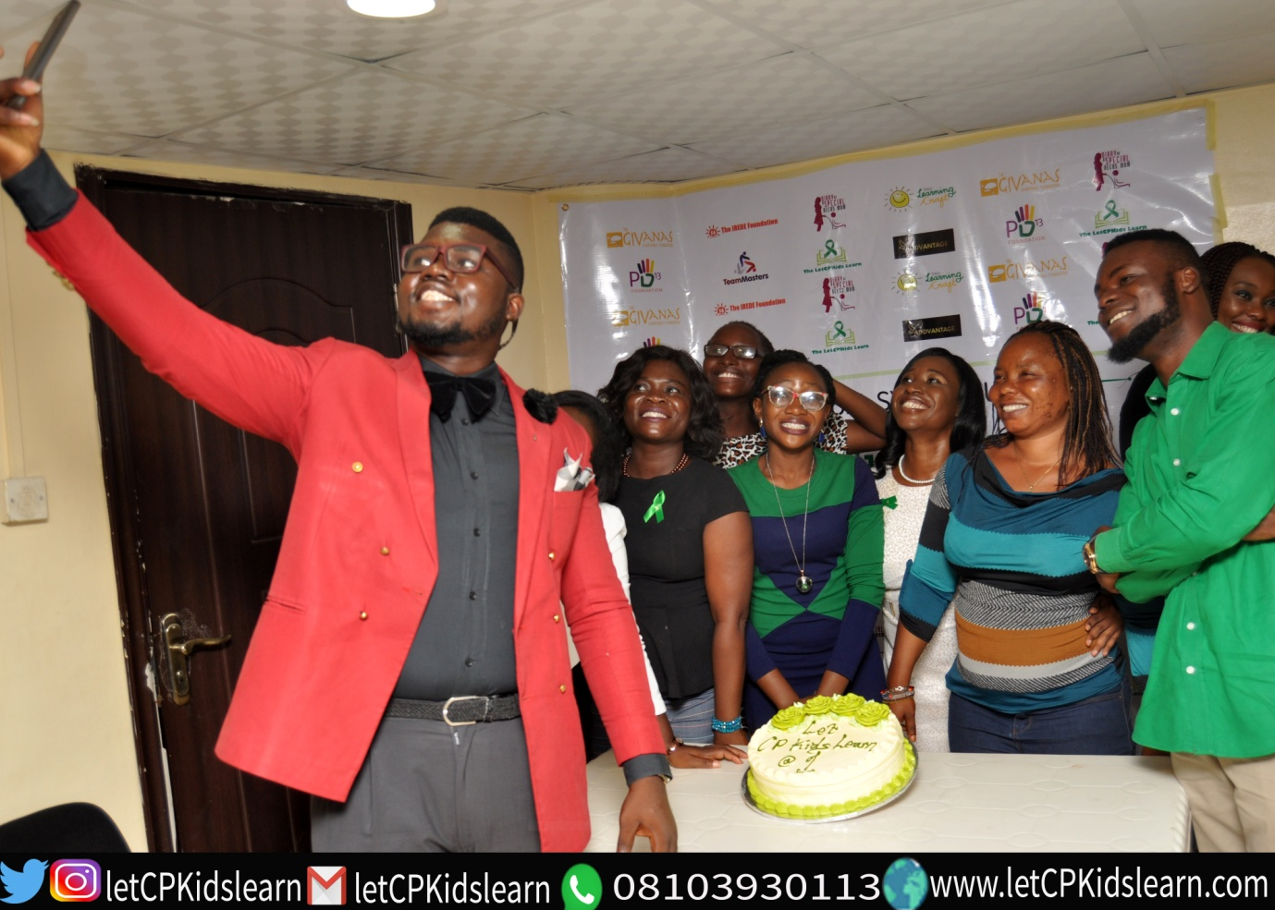
Volunteers!!!

How Can You Help Us Do More?
In a country where 1 in every 90 children born is diagnosed with Cerebral palsy, leading to at least 40,000 children diagnosed every year, we need to reach more families with the support that they need, and we need to equip more teachers and schools with the right tools to ensure that all children with Cerebral Palsy who are willing to learn are able to access quality and inclusive education.
You can help us to achieve our goals by:
  - Referring a child to us who needs any of our services
  - Sponsoring Teachers to attend our trainings
  - Sponsoring A child’s Education through our scholarship fund
  - Donating Cerebral Palsy Friendly equipment and learning aids/ materials
  - Cash donations to offset our Overhead costs to help us reach more families.

