Annual Report
2017
Tobiloba Ajayi
The Let CP Kids Learn project
12/31/2017
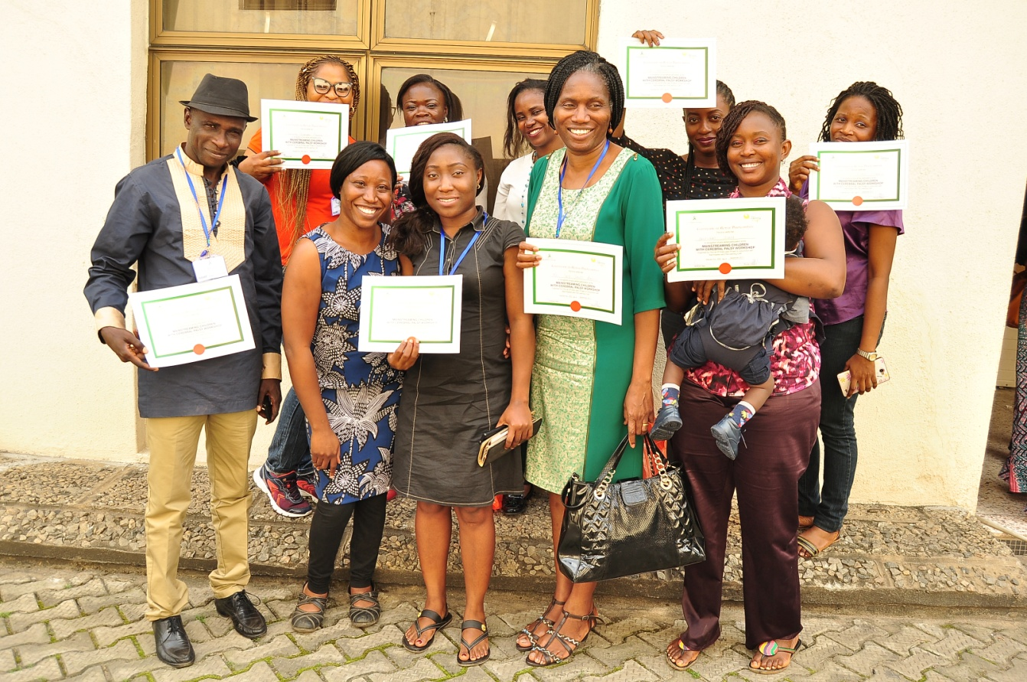

The Let CP Kids Learn Project Annual Report 2017
Table of Contents
Who We Are 2
From The Chief Responsibility Officer 3
What We Got Up To This Year 4
Public Awareness 4
Physical and School Readiness Assessments 5
Referrals 5
School Placement Support 6
Inclusive Education Support for schools 6
Teacher Training 7
Money Matters 7-8
You Made It All Happen 9
How Can You Help? 10

Who We Are

Our Vision
A Nigeria where children with Cerebral palsy are offered inclusive mainstream education as a first option as a right and not as the exception that currently exists
Our Mission
- Changing public perception about the intellectual capabilities of Children with Cerebral Palsy through public enlightenment programmes.

- Encouraging and supporting parents to raise their children with Cerebral palsy in their own homes and communities, including educating them in mainstream schools.

- Providing Support to Parents in the Management of Cerebral Palsy using a robust referral system

- Providing support to teachers, tutors and schools to enable them enrol, engage and support children with Cerebral palsy in mainstream classrooms

- Providing trainings and support materials to both families and teachers to help them understand Cerebral Palsy and ways to teach children with the condition.

From The Chief Responsibility Officer
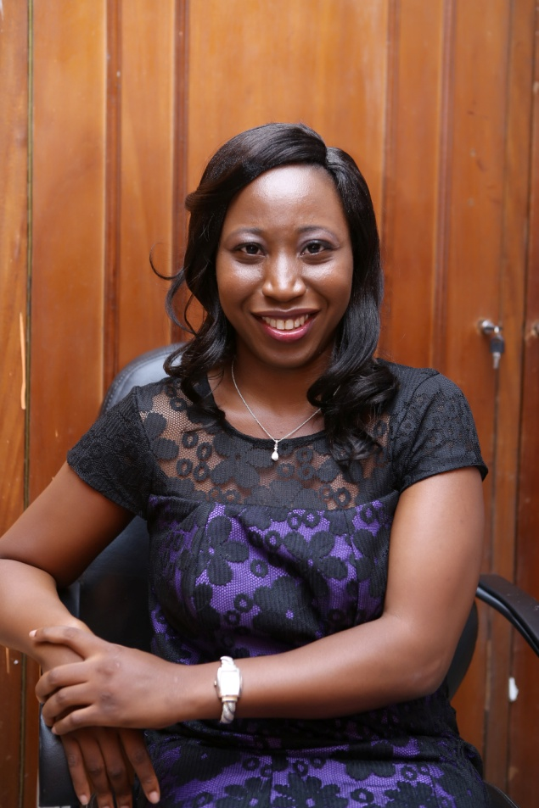

The Let CP Kids Learn Project started as a concern.
A concern that grew into a huge discontent
. A discontent about a nation’s perception about the intellectual capabilities of children with Cerebral Palsy and their place in society.
This discontent has in this one year grown. It has grown into a national movement that is changing perceptions about the intellectual capacities and educational capacities of children with Cerebral Palsy.
It has grown into a movement that has challenged age long beliefs, cultural norms and presumptions about what is possible with a Cerebral Palsy diagnosis and is continuing to change narratives along the way.
This year was our year of ‘testing’. With an unshakeable belief in the capacity of children with Cerebral Palsy to learn, we set out this year to share that knowledge with the world and help as many children with Cerebral Palsy as we could reach access an education that is inclusive and prepares them for life.
This year has been a roller coaster in all the ways possible, but as we close this year, we can look back and indeed say that we have fulfilled our mission of promoting inclusive mainstream education for children with Cerebral Palsy in Nigeria

Tobiloba Ajayi
Chief Responsibility Officer

2017 Impact across Our Thematic Areas

Public Awareness
Social Media was our biggest too; of public awareness in 2017. Using the LetCPKidsLearn Hash tag we reached thousands of people across the various social media platforms.
Particularly, in March we ran a 31 day awareness campaign where we shared one Cerebral palsy fact every day for the month of March.
We also had twitter chats with education experts on inclusive education

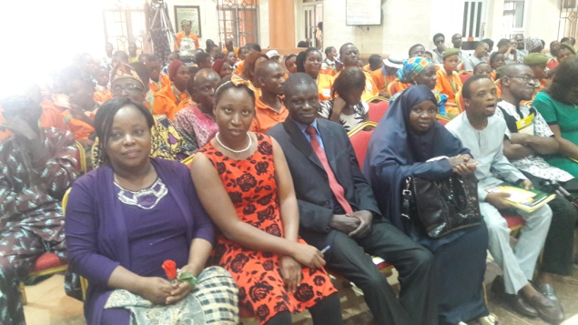
Speaking at The Breaking All Barriers Club Public Presentation
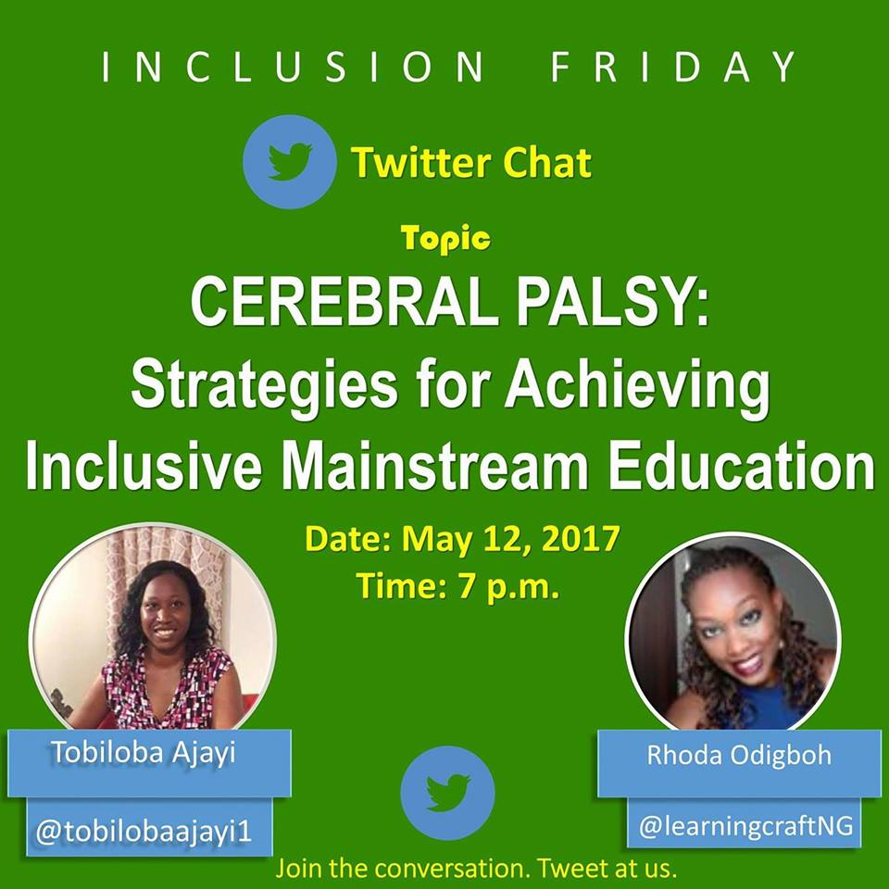

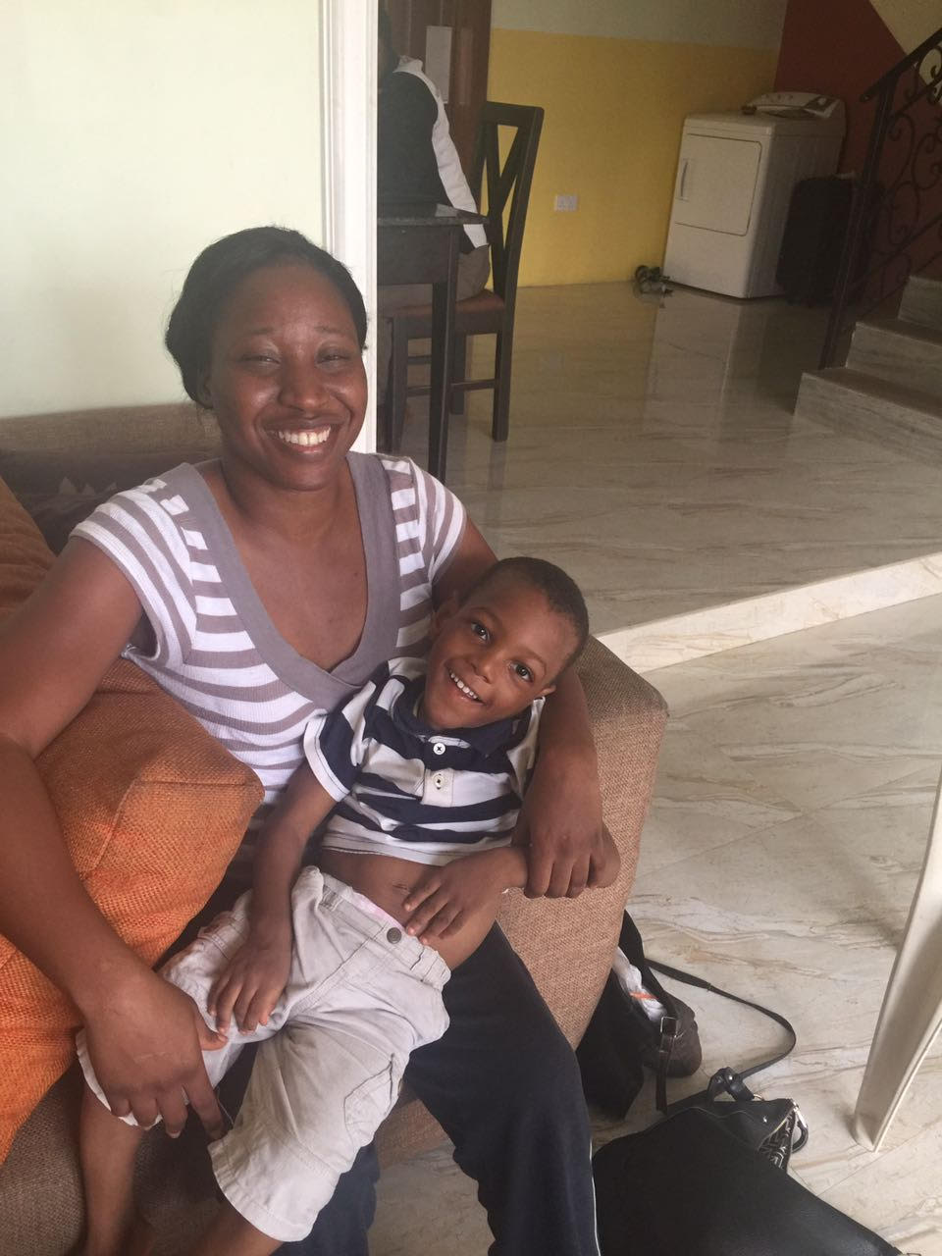

Physical School Readiness Assessments
We provided Physical and School Readiness Assessments to 56 people, 29 Male, 27 Females ranging between the ages of 6 months to 36 years old.

After Assessment Pictures

Referrals
All 56 people assessed were given appropriate referrals as required for their needs.
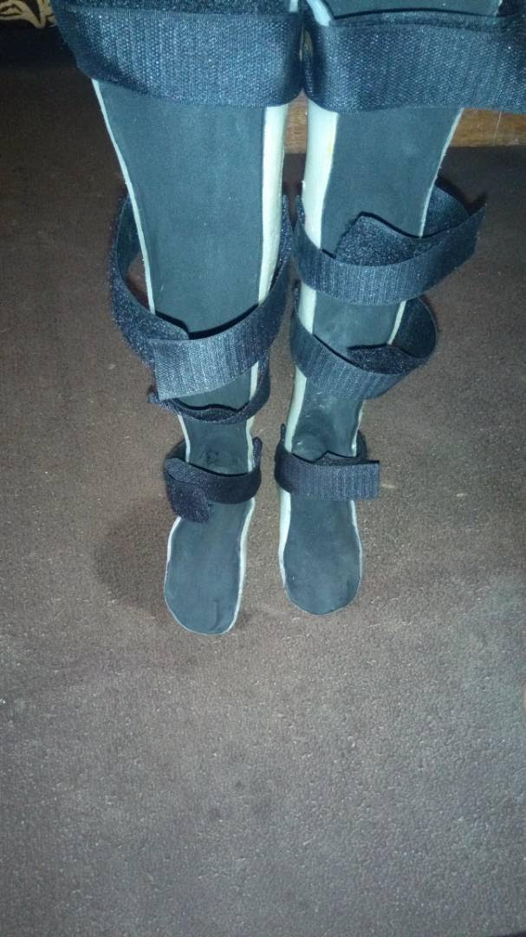
Knee Ankle Foot Orthotics made on Referral to an orthotist

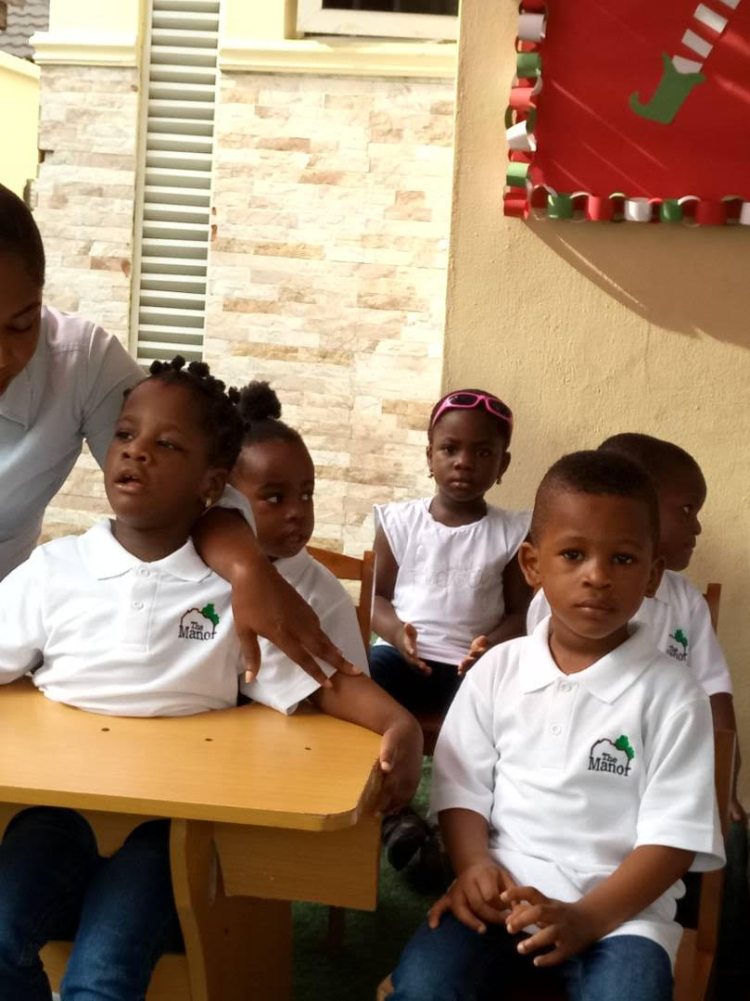
School Placement Support
One of our children in class with her peers
26 children were placed into
Mainstream schools this year
in 12 different schools across 5 states
of the country.

Inclusive Education Support For Schools
We provided ongoing inclusive education support for two schools in Lagos State this year.

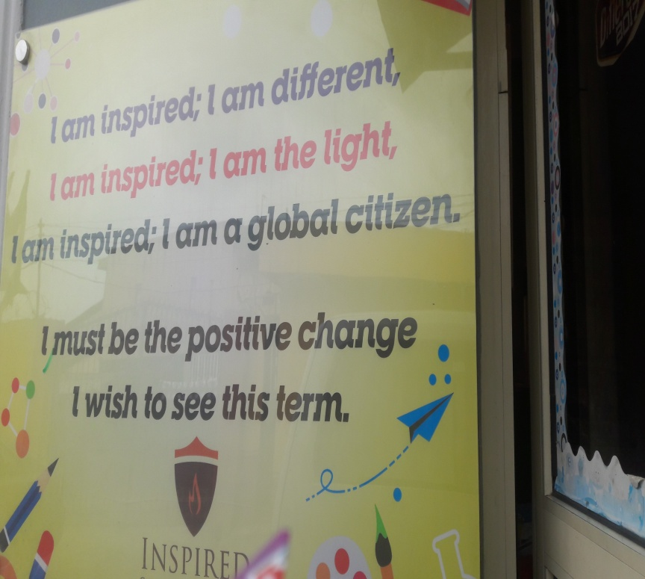
Inspired Christian Learning Centre, One of the schools we provided support to this year

Teacher Training
We trained 15 teachers on appropriate techniques for mainstreaming children with Cerebral Palsy
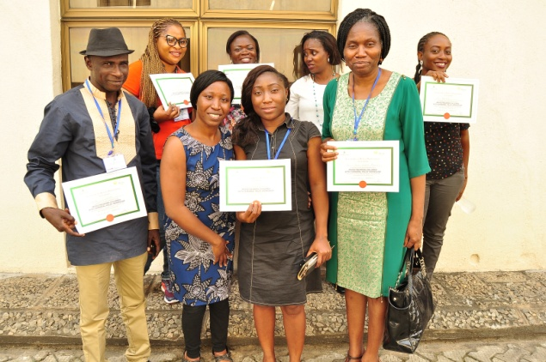

What Did This Cost?

Total Expenditure = N685, 200

Total Income: N435, 000

2017 Financial Deficit: N250, 200

You Made It All Happen!
We are incredibly grateful to all our Donors, Partners, family and friends for your repeated unending support which made all this possible. You are the dream team who make the dream work.
Without your support, this would have been another beautiful idea that never saw the light of day.
To all our parents, who gave us the privilege to work with you this year, you are our Most Valuable Assets. Thank you for joining us to believe that
children with Cerebral Palsy can learn 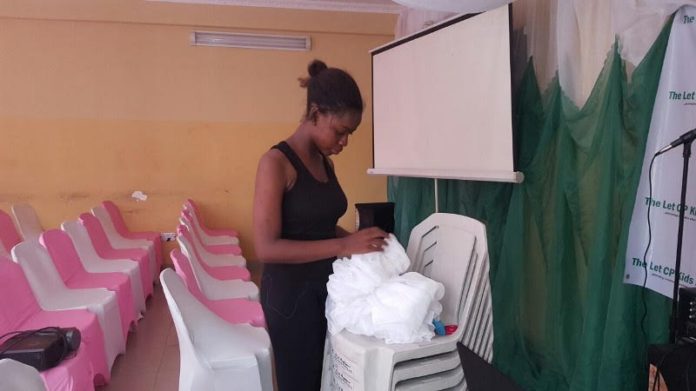 A volunteer setting up an event venue

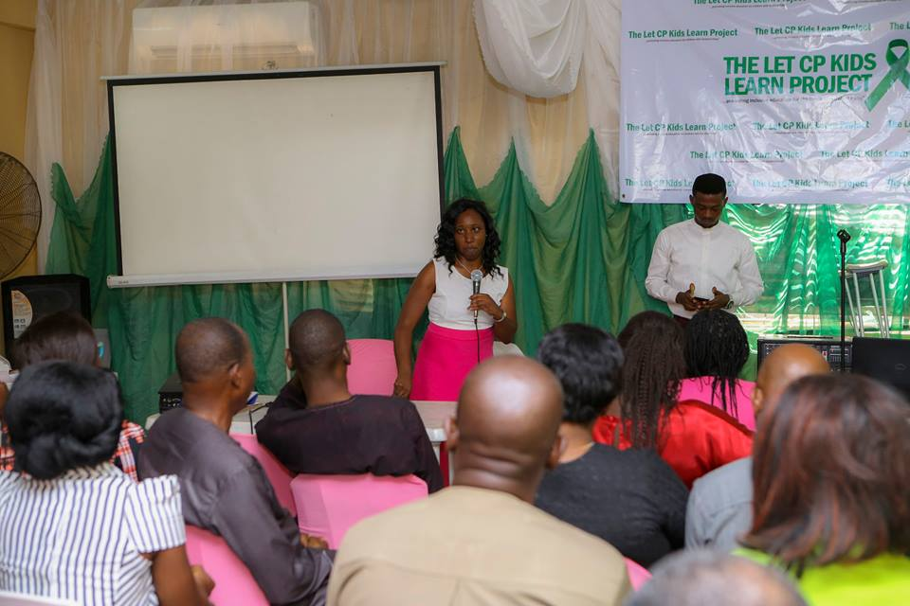
Parents and Educators at the official flag off

How Can You Help?
1n the year 2017, only 24% of our income came from external sources. 12% came from donations and the other 12% from training fees. The remaining 76% of the expenditure was from personal funds.
In a country where 1 in every 90 children born is diagnosed with Cerebral palsy, leading to at least 40,000 children diagnosed every year, we need to reach more families with the support that they need , and we need to equip more teachers and schools with the right tools to ensure that all children with Cerebral Palsy who are willing to learn are able to access quality and inclusive education .
You can help us by:
  - Referring a child to us who needs any of our services
  - Sponsoring Teachers to attend our trainings
  - Sponsoring A child’s Education
  - Donating Cerebral Palsy Friendly equipment and learning materials
  - Cash donations to offset our Overhead costs to help us do more.

